1. **Favicon is not displayed on the all pages**

Steps

1. Go to the demo.guru99 site.
2. Pay attention to the favicon

Actual result

Favicon is not displayed on the all pages.

Expected result

Favicon is displayed on the all pages.

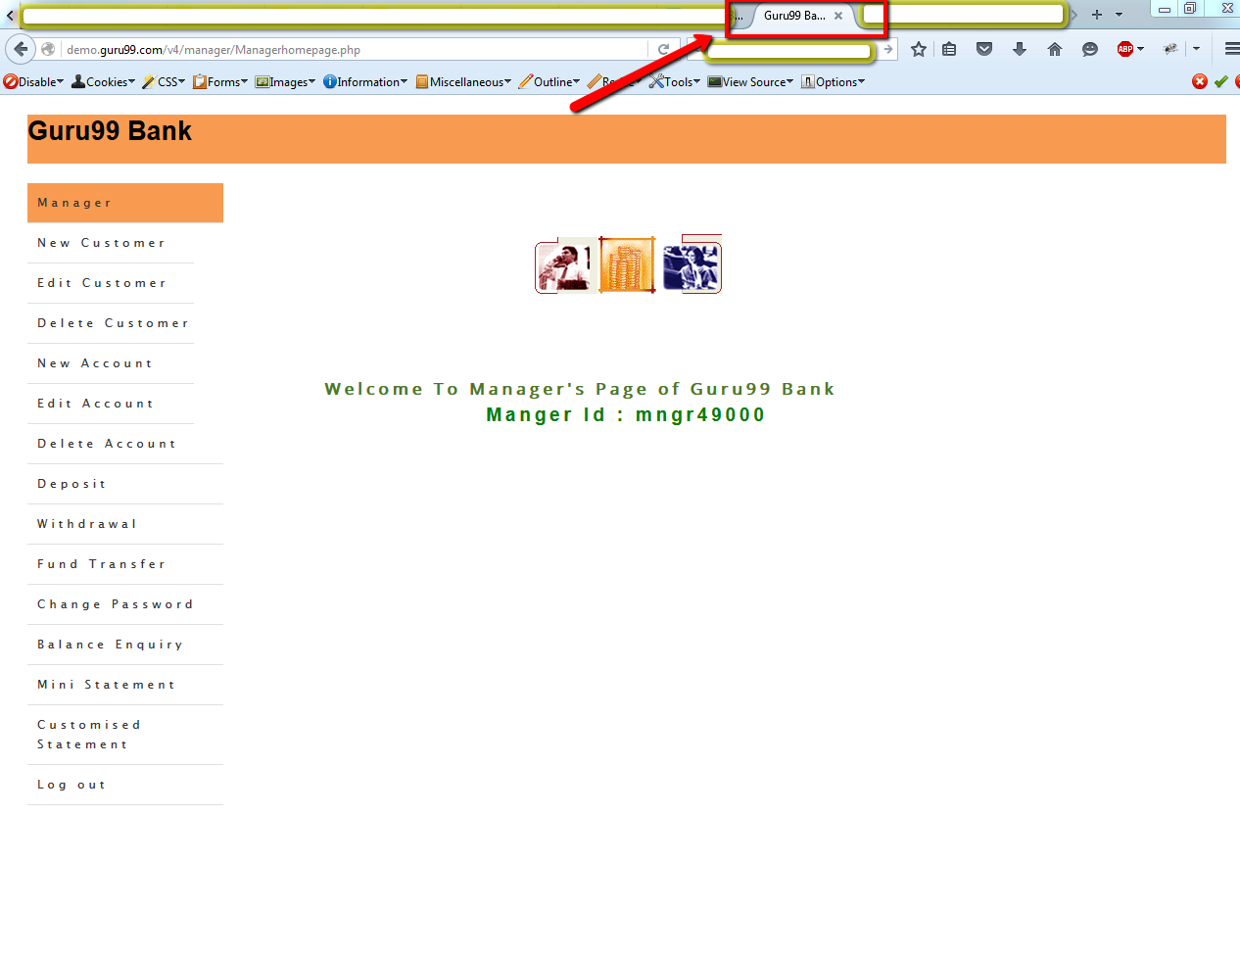

1. **The “Manger” word is displayed on the main page**

Steps

1. Go to the guru99 site
2. Log in to the system
3. Pay attention to the “Manger Id:” form

Actual result

The “Manger” word is displayed on the main page

Expected result

The “Manager” word is displayed on the main page

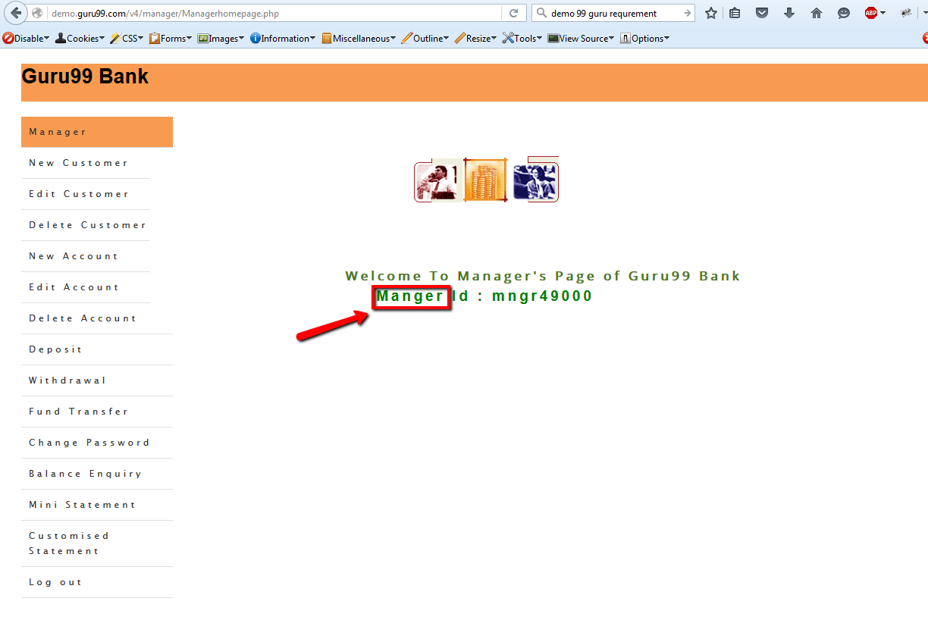

1. **The “home” word(lower case) is displayed on the “New Account” page**

Steps

1. Go to the guru99 site
2. Login to the system
3. Go to the “New Account” page
4. Pay attention to the “home” link

Actual result

The “home” word(lower case) is displayed on the “New Account” page

Expected result

The “Home” word(upper case) is displayed on the “New Account” page

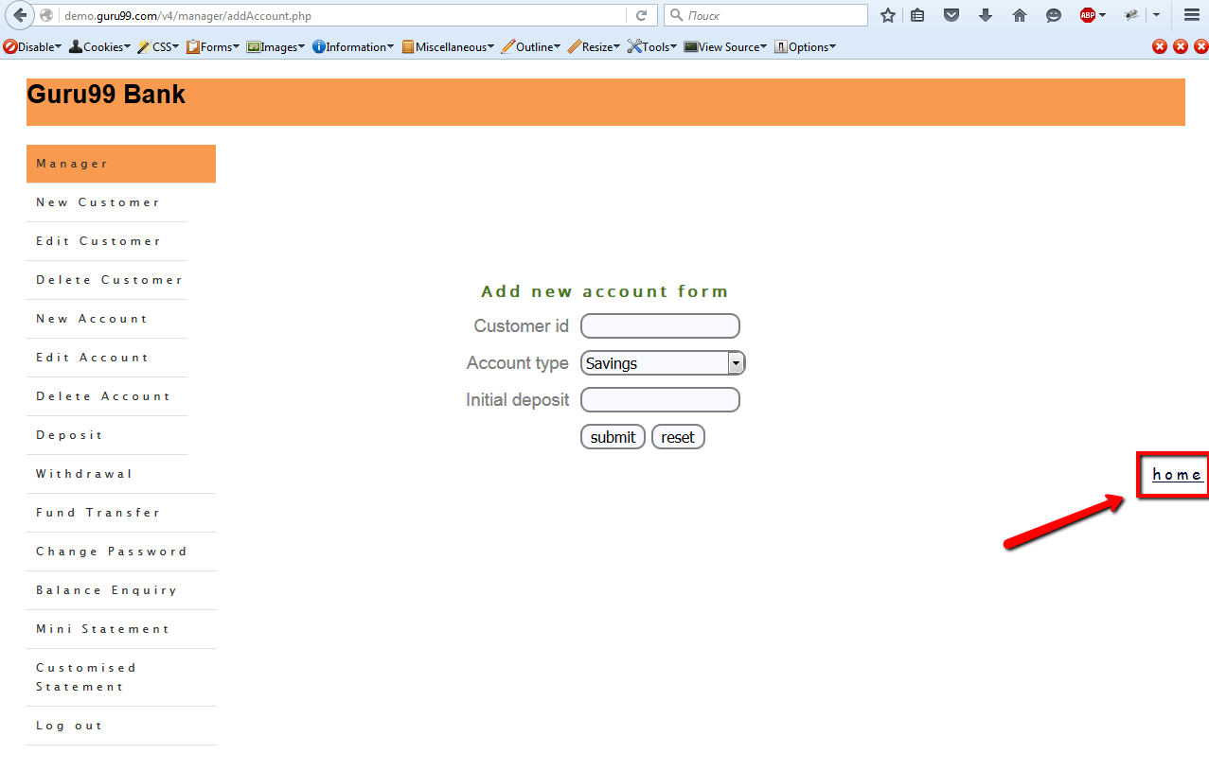

1. **The “submit” and “reset” buttons are displayed with lower case on the “New Account” page**

Steps

1. Go to the guru99 site
2. Login to the system
3. Go to the “New Account” page
4. Pay attention to the “submit” and “reset” buttons

Actual result

The “submit” and “reset” buttons are displayed with lower case on the “New Account” page

Expected result

The “Submit” and “Reset” buttons are displayed with upper case on the “New Account” page

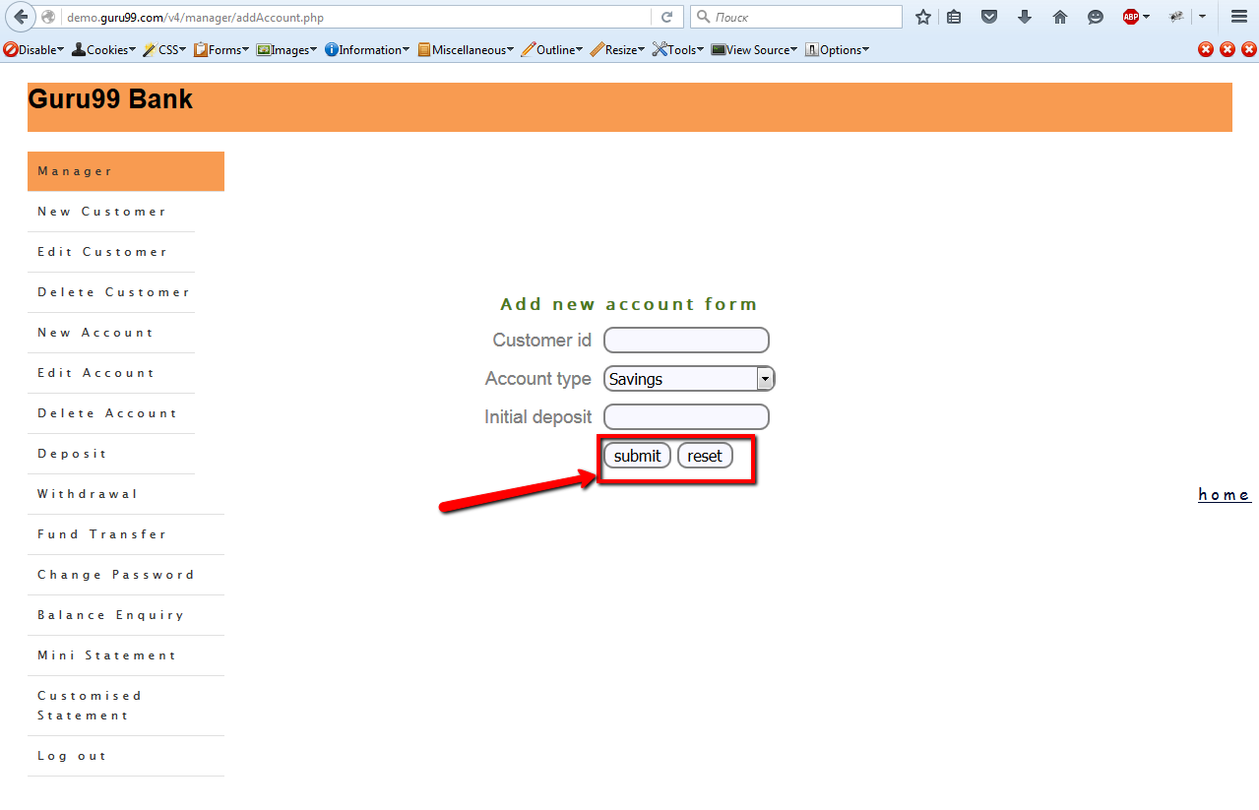

1. **The “Form” word is missed on the “Fund Transfer” page**

Steps

1. Log in to the guru99 system
2. Go to the “Fund Transfer” page
3. Pay attention to the name form

Actual result

The “Form” word is missed on the “Fund Transfer” page

Expected result

The “Fund transfer form” label is displayed on the “Fund Transfer” page

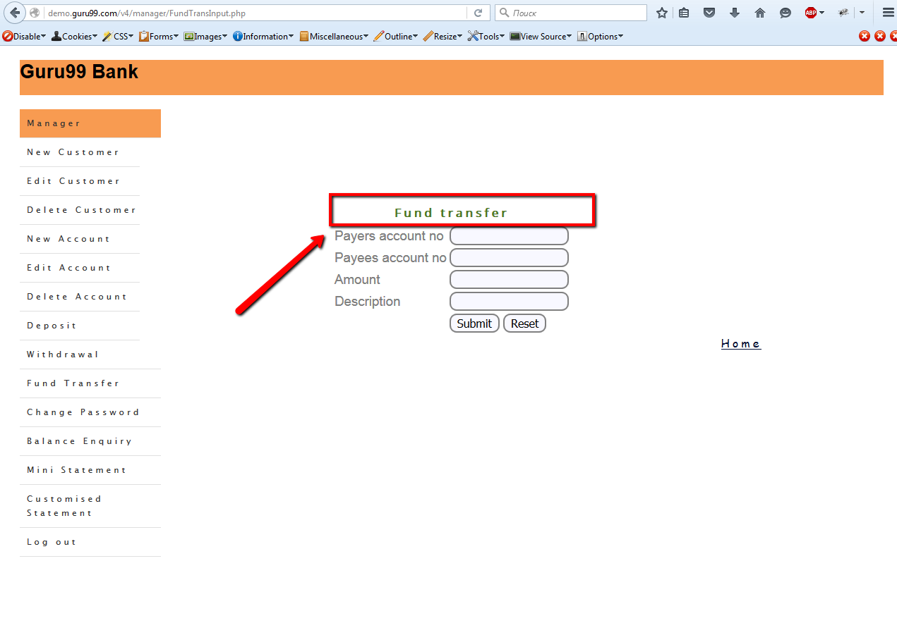

1. **The “Form” word is missed on the “Change password” page**

Steps

1. Log in to the guru99 system
2. Go to the “Change password” page
3. Pay attention to the name form

Actual result

The “Form” word is missed on the “Change password” page

Expected result

The “Change password form” label is displayed on the “Change password” page

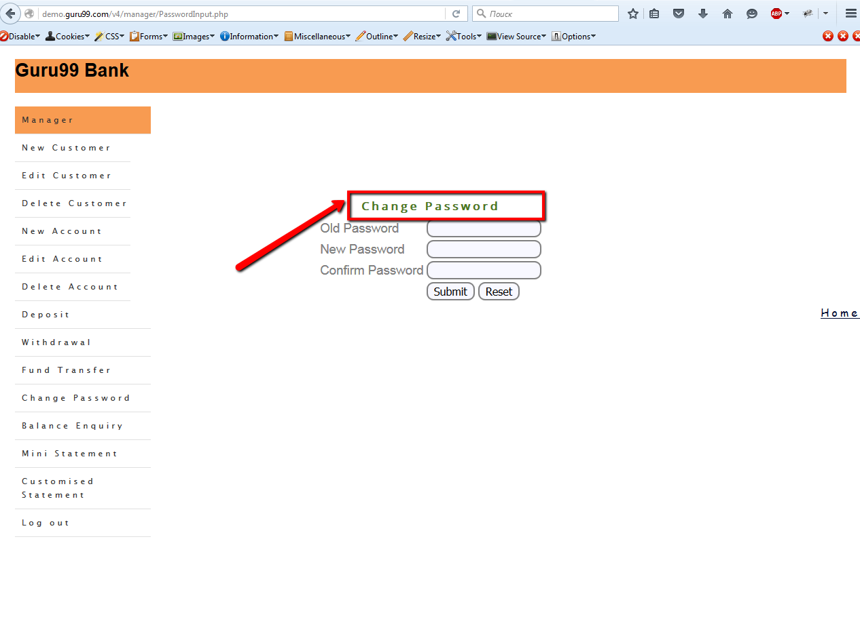

1. **The “Add New Customer” form is displayed on the navigation menu after resizing the “Address” field**

Steps

1. Log in to the guru99 system
2. Go to the “New Customer” page
3. Resize the “Address” field

Actual result

The “Add New Customer” form is displayed on the navigation menu after resizing the “Address” field

Expected result

The “Add New Customer” form is not displayed on the navigation menu after resizing the “Address” field

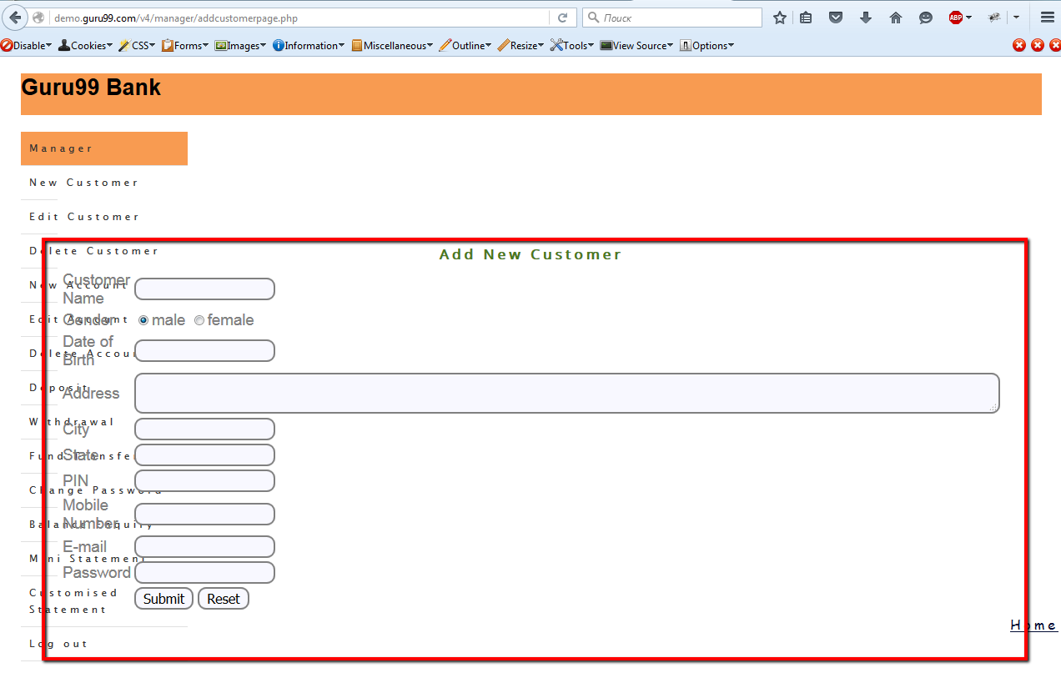

1. **The “Form” word is missed on the “New Customer” page**

Steps

1. Log in to the guru99 system
2. Go to the “New Customer” page
3. Pay attention to the name form

Actual result

The “Form” word is missed on the “New Customer” page

Expected result

The “New Customer form” label is displayed on the “New Customer” page

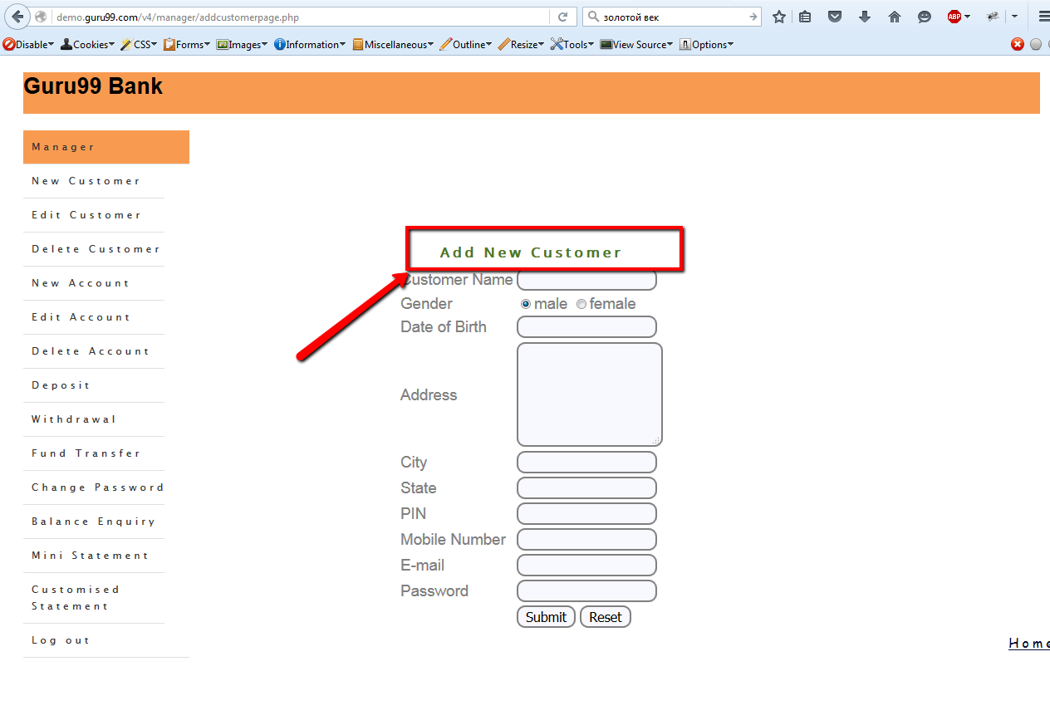

1. **All transactions are displayed on the “Customized Statement” page after choosing transaction by number**

Steps

1. Go to the guru99 system
2. Go to the “Customized Statement” page
3. Fill in the correct “Account No” and the “Number of transaction” fields
4. Click the “ Submit” button
5. Pay attention to the transaction details

Actual result

All transactions are displayed on the “Customized Statement” page after choosing transaction by number

Expected result

The one transaction is displayed on the “Customized Statement” page after choosing transaction by number

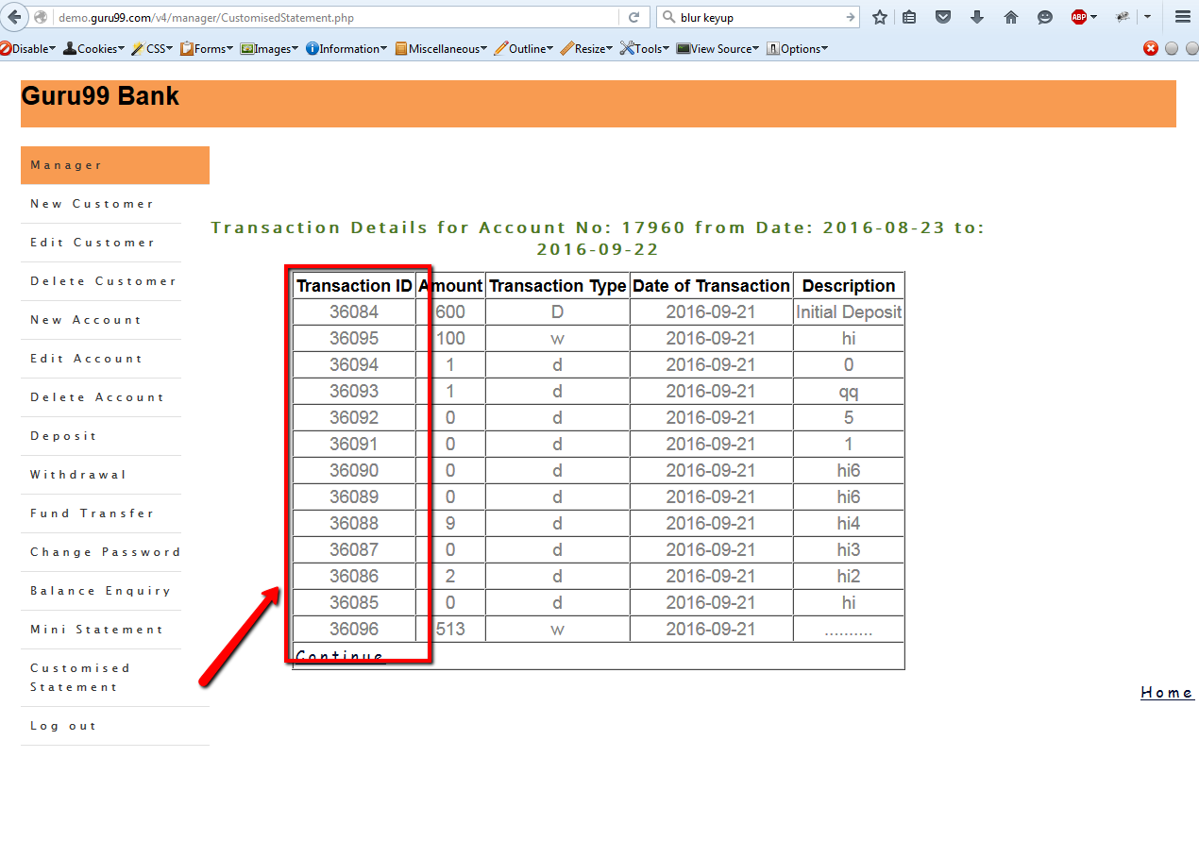

1. **The “Customer Name”, the “Gender”, the “Date of Birth” fields are disabled on the “Edit Customer” page**

Steps

1. Go to the guru99 system
2. Create new customer
3. Go to the “Edit Customer” page
4. Fill in the “Customer ID” field correct data
5. Click the “Submit” button
6. Pay attention to the “Customer Name”, the “Gender”, the “Date of Birth” fields

Actual result

The “Customer Name”, the “Gender”, the “Date of Birth” fields are disabled on the “Edit Customer” page

Expected result

The “Customer Name”, the “Gender”, the “Date of Birth” fields are enabled on the “Edit Customer” page

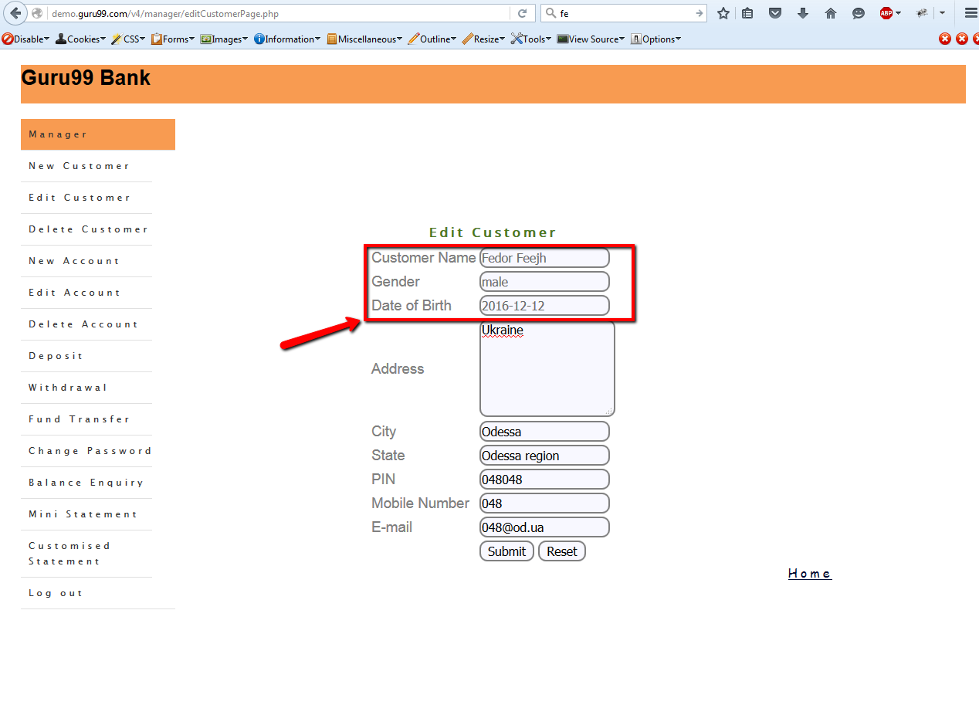

1. **The error message is not shown on the “Edit Customer” page after filling the “Address”, the “City“, the “State”, the “PIN”, the “Mobile Number”, “the E-mail” fields blank**

Steps

1. Go to the guru99 system
2. Go to the “Edit Customer” page
3. Fill in the “Customer ID” field correct data
4. Click the “Submit” button
5. Delete all information on the “Address”, the “City“, the “State”, the “PIN”, the “Mobile Number”, “the E-mail” fields
6. Click the “Submit” button
7. Pay attention to the lack of error message

Actual result

The error message is not shown on the “Edit Customer” page after filling the “Address”, the “City“, the “State”, the “PIN”, the “Mobile Number”, “the E-mail” fields blank

Expected result

The error message is shown on the “Edit Customer” page after filling the “Address”, the “City“, the “State”, the “PIN”, the “Mobile Number”, “the E-mail” fields blank

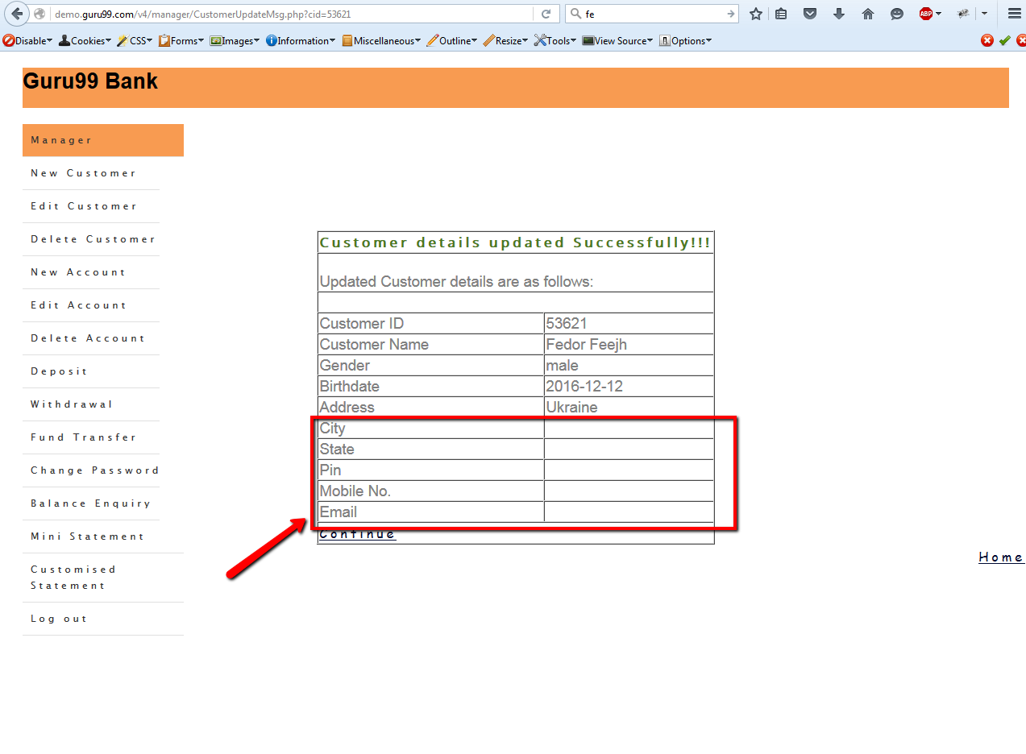

1. **The “Birthdate” field is displayed on the “Edit Customer” page after clicking the “Submit” button**

Steps

1. Go to the guru99 system
2. Go to the “Edit Customer” page
3. Fill in the “Customer ID” field correct data
4. Click the “Submit” button
5. Change any field
6. Click the “Submit” button
7. Pay attention to the “Birthdate” field

Actual result

The “Birthdate” field is displayed on the “Edit Customer” page after clicking the “Submit” button

Expected result

The “Date of Birth” field is displayed on the “Edit Customer” page after clicking the “Submit” button

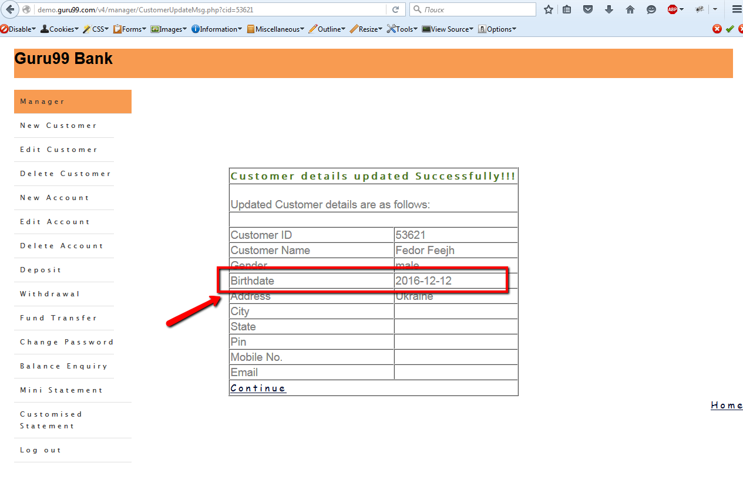

1. **The “Pin” field is displayed on the “Edit Customer” page after clicking the “Submit” button**

Steps

1. Go to the guru99 system
2. Go to the “Edit Customer” page
3. Fill in the “Customer ID” field correct data
4. Click the “Submit” button
5. Change any field
6. Click the “Submit” button
7. Pay attention to the “Pin” field

Actual result

The “Pin” field is displayed on the “Edit Customer” page after clicking the “Submit” button

Expected result

The “PIN” field is displayed on the “Edit Customer” page after clicking the “Submit” button

1. **The “Mobile No.” field is displayed on the “Edit Customer” page after clicking the “Submit” button**

Steps

1. Go to the guru99 system
2. Go to the “Edit Customer” page
3. Fill in the “Customer ID” field correct data
4. Click the “Submit” button
5. Change any field
6. Click the “Submit” button
7. Pay attention to the “Mobile No.” field

Actual result

The “Mobile No.” field is displayed on the “Edit Customer” page after clicking the “Submit” button

Expected result

The “Mobile Number” field is displayed on the “Edit Customer” page after clicking the “Submit” button

1. **The “Email” field is displayed on the “Edit Customer” page after clicking the “Submit” button**

Steps

1. Go to the guru99 system
2. Go to the “Edit Customer” page
3. Fill in the “Customer ID” field correct data
4. Click the “Submit” button
5. Change any field
6. Click the “Submit” button
7. Pay attention to the “Email” field

Actual result

The “Email” field is displayed on the “Edit Customer” page after clicking the “Submit” button

Expected result

The “E-mail” field is displayed on the “Edit Customer” page after clicking the “Submit” button

1. **The “Password” field is not displayed on the “Edit Customer” page**

Steps

1. Go to the guru99 system
2. Create new customer
3. Go to the “Edit Customer” page
4. Fill in the “Customer ID” field correct data
5. Click the “Submit” button
6. Pay attention to the lack of the “password” field

Actual result

The “Password” field is not displayed on the “Edit Customer” page

Expected result

The “Password” field is displayed on the “Edit Customer” page

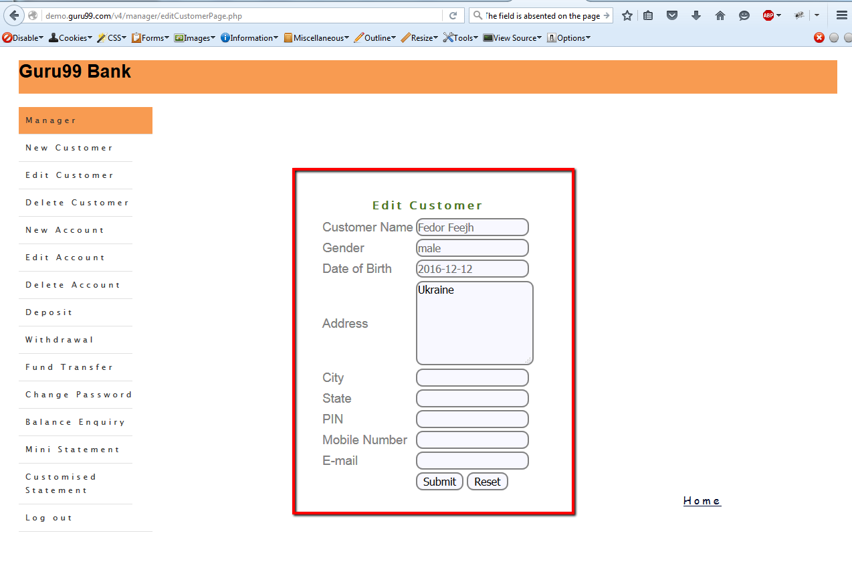

1. **The “1970-01-01” date field is shown on the “New Customer” page after filling invalid date of birth**

Steps

1. Go to the guru99 system
2. Go to the “New Customer” page
3. Fill in the valid data and fill in the “Date of birth” invalid date
4. Click the “Submit” button
5. Pay attention to the lack of error message

Actual result

The “1970-01-01” date field is shown on the “New Customer” page after filling invalid date of birth

Expected result

The “Date of Birth” field is incorrect” error message is shown on the “New Customer” page after filling invalid date of birth

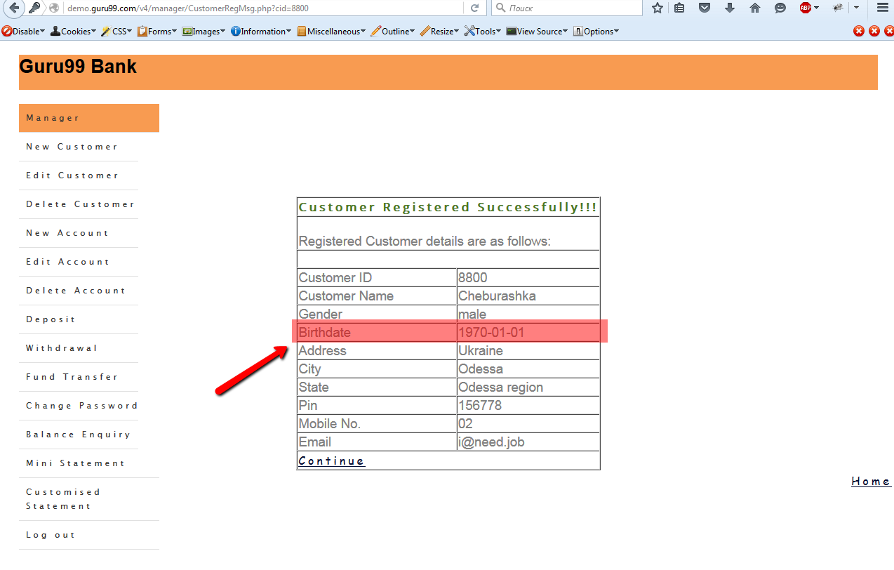

1. **All input fields are not cleared on the “Edit Customer” page after clicking the “Reset” button**

Steps

1. Go to the guru99 system
2. Go to the “Edit Customer” page
3. Fill in the “Customer ID” field correct data
4. Click the “Reset” button
5. Pay attention to the “Edit Customer” form

Actual result

All input fields are not cleared on the “Edit Customer” page after clicking the “Reset” button

Expected result

All input fields are cleared on the “Edit Customer” page after clicking the “Reset” button

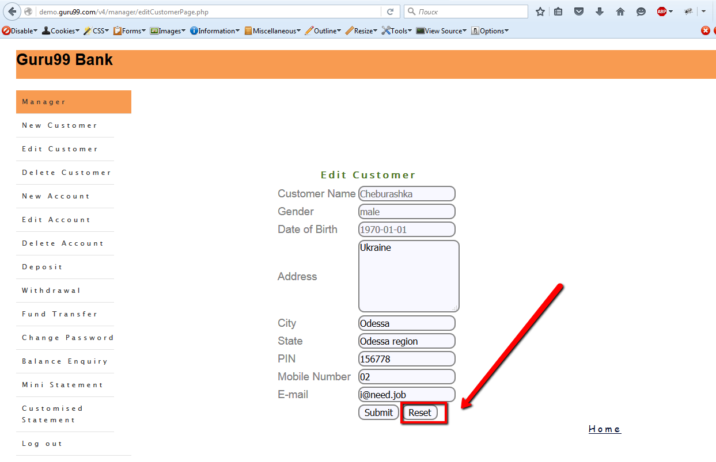

1. **A datepicker is not shown on the “Edit Customer” page and on the “Customized Statement” page using MozillaFireFox 43 and InternetExplorer 11**

Steps

1. Open the browser MozillaFireFox 43 or InternetExplorer 11
2. Go to the guru99 system
3. Go to the “Edit Customer” page
4. Pay attention to the lack of datepicker on the “Address” field

Actual result

A datepicker is not shown on the “Edit Customer” page and on the “Customized Statement” page using MozillaFireFox 43 and InternetExplorer 11

Expected result

A datepicker is shown on the “Edit Customer” page and on the “Customized Statement” page using MozillaFireFox 43 and InternetExplorer 11

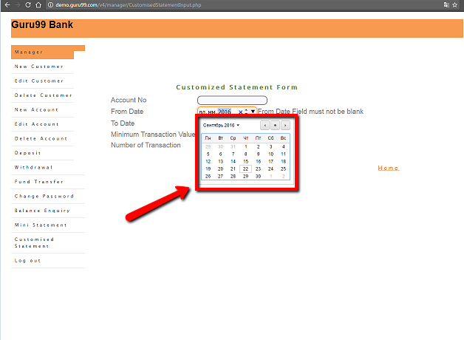

1. **The “Welcome To Manager's Page of Guru99 Bank” label is moved with different speed on the different browsers**

Steps

1. Go to guru99 system with different browsers
2. Pay attention to the “Welcome To Manager's Page of Guru99 Bank” on the main page

Actual result

The “Welcome To Manager's Page of Guru99 Bank” label is moved with different speed on the different browsers

Expected result

The “Welcome To Manager's Page of Guru99 Bank” label is moved with same speed on the different browsers